NETWORK SECURITY, MAINTENANCE AND TROUBLESHOOTING PROCESS

SECURE NETWORK WITH FIREWALL NAT
TASK1: Set up Windows Defender Firewall on your Windows laptop or PC and create a new inbound rule to block all incoming traffic on port 8080. Take a screenshot of the rule you created.
- Press Windows + S and search for Windows Defender Firewall with Advanced Security.
- Open the application.
- Click Inbound Rules from the left panel.
- Click New Rule... on the right side.
- Select Port and click Next.
- Select TCP.
- Choose Specific local ports and enter: 8080
- Click Next.
- Select Block the connection.
- Click Next.
- Keep Domain, Private, and Public checked.
- Click Next.
- Enter the rule name: Block Port 8080
- Click finish
TASK2: Simulate NAT (Network Address Translation) by drawing a simple diagram showing how your home WiFi router assigns private IP addresses to your phone, laptop, and smart TV, and how it translates them to a single public IP for internet access.<br><br><em><strong>Hint:</strong> Use any drawing tool or even hand-draw and click a photo.</em>
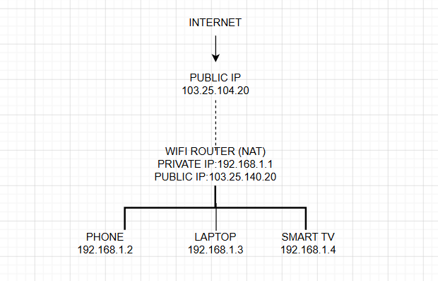
EXPLANATION:
- The router gives private IP addresses to all devices.
- When devices access the internet, the router converts all private IPs into one public IP using NAT.
TASK3: Configure port filtering using your WiFi router's admin panel (or use a router simulator online if you don't have access). Block outgoing traffic on port 25 (SMTP) and explain in 2 sentences how this could help prevent spam from your network.
- Open a web browser.
- Type your router IP address: 192.168.1.1 OR 192.168.0.1
- Log in using the router username and password.
- Open Firewall or Security settings.
- Select Port Filtering or Access Control.
- Click Add New Rule.
- Select Outbound Rule.
Enter: Port Number: 25
Protocol: TCP
Action: Block
- Save the settings.
- Restart the router if required.
TASK4: Given a sample packet filtering rule set (provided by your trainer), identify which of these three sample packets would be allowed or blocked: 1) HTTP request from 192.168.1.5 to 172.217.166.78:80, 2) SSH request from 10.0.0.10 to 34.201.23.1:22, 3) DNS query from 192.168.1.7 to 8.8.8.8:53.<br><br><em><strong>Hint:</strong> Focus on source/destination IPs and ports in the rule set.</em>.

SUPPOSE THE RULE IS :
Source Network | Destination | Port | Protocol | Action
192.168.1.0/24 | Any | 80 | TCP/HTTP | ALLOW

IT MEANS • 192.168.1.0/24 → Source must be from the 192.168.1.x network.
- Port 80 → HTTP traffic.
- ALLOW → Packet is permitted.
- Source IP
↓
2. Destination IP
↓
3. Destination port
↓
4. Protocol
↓
5. Compare with HTTP rule
↓
6. Allow or Block
HTTP REQUEST:
Source IP = 192.168.1.5
Destination IP = 172.217.166.78
Port = 80
Protocol = HTTP
Step 1: Check Source IP
Source is:
192.168.1.5
The rule allows:
192.168.1.0/24
192.168.1.5 belongs to this network.
Step 2: Check Destination IP
Destination is:
172.217.166.78
The HTTP rule allows traffic to any destination.
Step 3: Check Port
Port is:
80
HTTP normally uses:
Port 80
Step 4: Check Protocol
Packet is:
HTTP
The rule is for:
HTTP
Step 5: Apply the rule
Everything matches the HTTP rule.
SSH REQUIRMENT:
Source IP = 10.0.0.10
Destination IP = 34.201.23.1
Port = 22
Protocol = SSH
Step 1: Check Source IP
Source is:
10.0.0.10
The HTTP rule allows:
192.168.1.0/24
10.0.0.10 is not in that network.
Step 2: Check Destination IP
Destination is:
34.201.23.1
The HTTP rule allows any destination, so destination itself is not the problem.
Step 3: Check Port
Port is:
22
SSH uses:
Port 22
But the HTTP rule requires:
Port 80
Step 4: Check Protocol
Packet is:
SSH
But the rule is for:
HTTP
Step 5: Apply the rule
The packet does not match the HTTP rule.
DNS QUERY:
Source IP = 192.168.1.7
Destination IP = 8.8.8.8
Port = 53
Protocol = DNS
Step 1: Check Source IP
Source is:
192.168.1.7
The allowed network is:
192.168.1.0/24
192.168.1.7 belongs to this network.
Step 2: Check Destination IP
Destination is:
8.8.8.8
The HTTP rule allows any destination
Step 3: Check Port
Port is:
53
DNS normally uses:
Port 53
But HTTP uses:
Port 80
Step 4: Check Protocol
Packet is:
DNS
The rule is for:
HTTP
Step 5: Apply the rule
The packet does not satisfy the HTTP rule.

TASK5: Research and list 3 ways Instagram or Zomato might use firewalls and packet filtering to protect their servers from attacks or misuse.
1. Block Unauthorized Access
Firewalls block unknown users from directly accessing the company servers.
2. Filter Malicious Traffic
Packet filtering blocks harmful traffic, viruses, and hacking attempts before they reach the servers.
3. Protect User Data
Firewalls help secure users' login details, passwords, and payment information from attackers.

